GOOGLE CLOUD PROJECT

DEPLOY WEB APP



USING GCP



By: Ayush Milan

Project Work

Task 1. Create multiple projects namely developer and production

2 Projects with Project name and respective Project ID will be generated

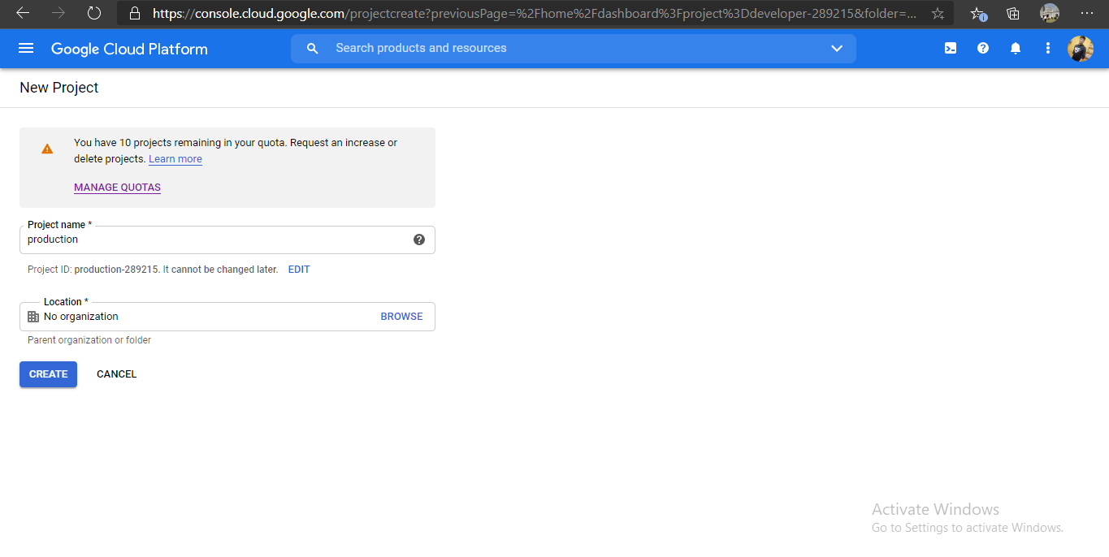

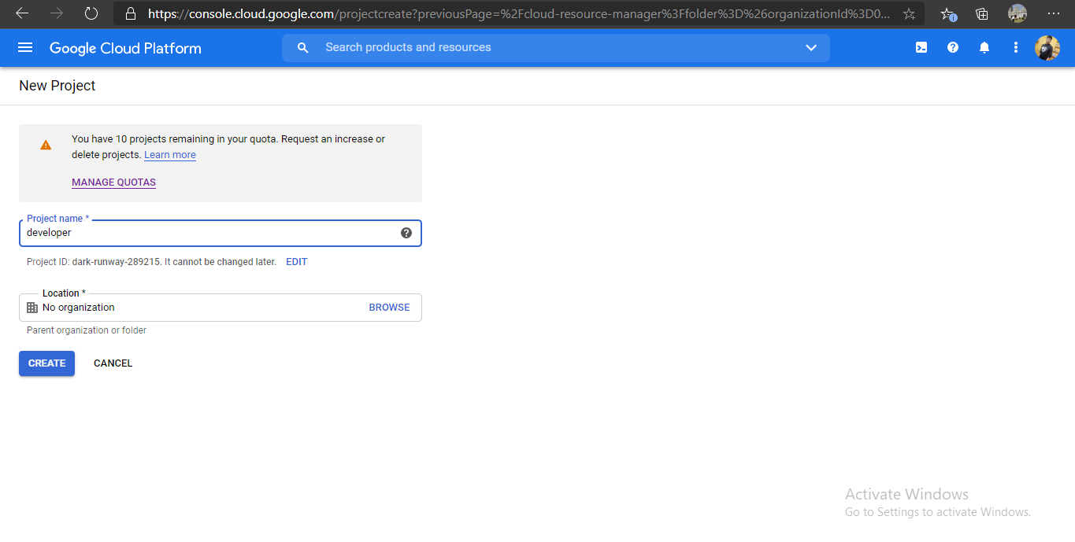

After creating the project we have to enable the billing for the projects and enable compute engine API ,so that we create the VPC networks.

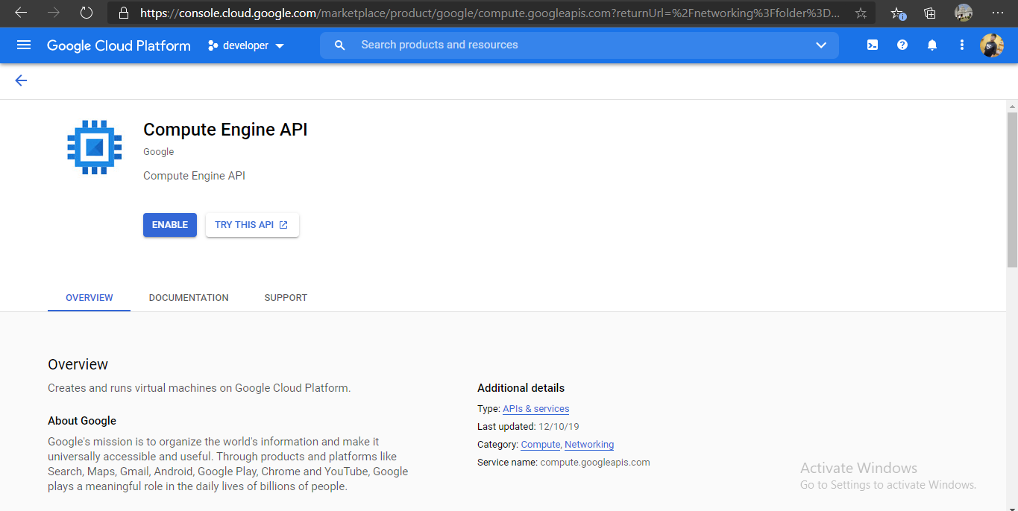

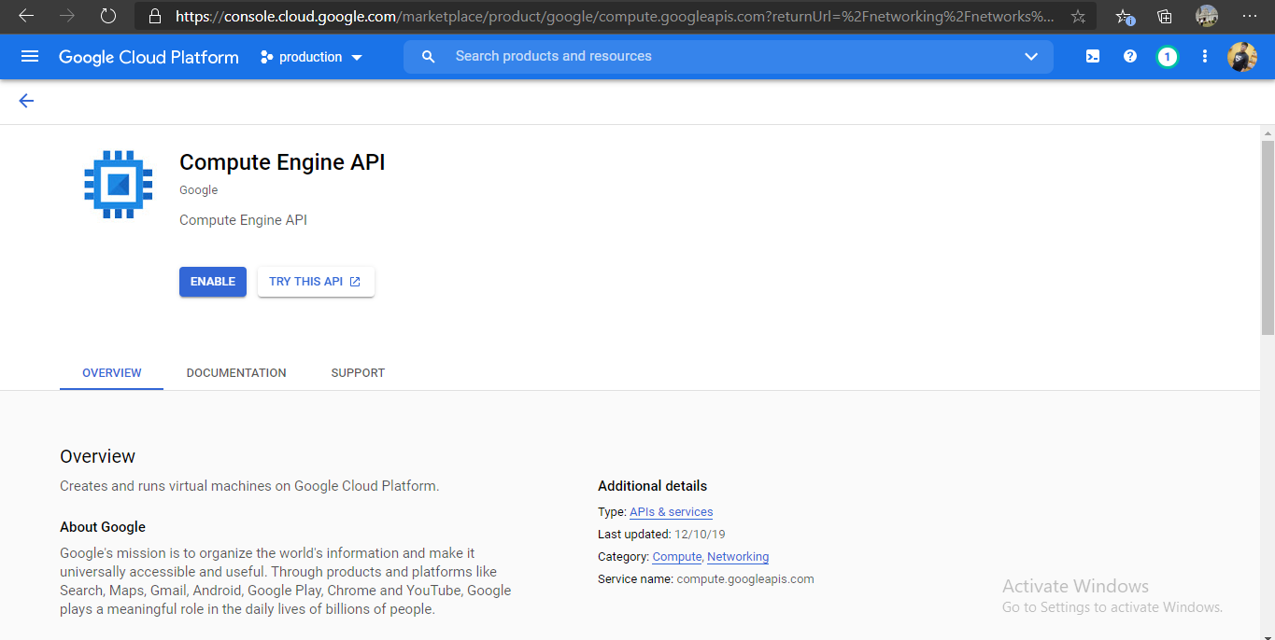

Task 2. Create VPC network for both the projects

Now we have to create vpc ,here i create vpc for developer project in asia-southeast1 region as lab1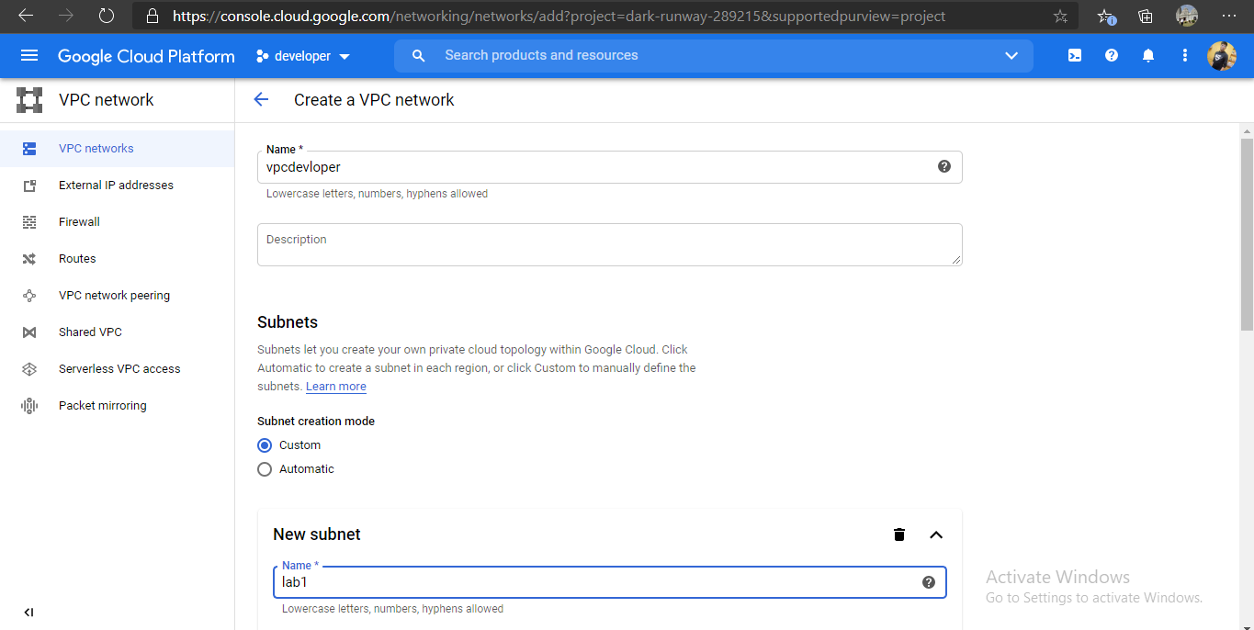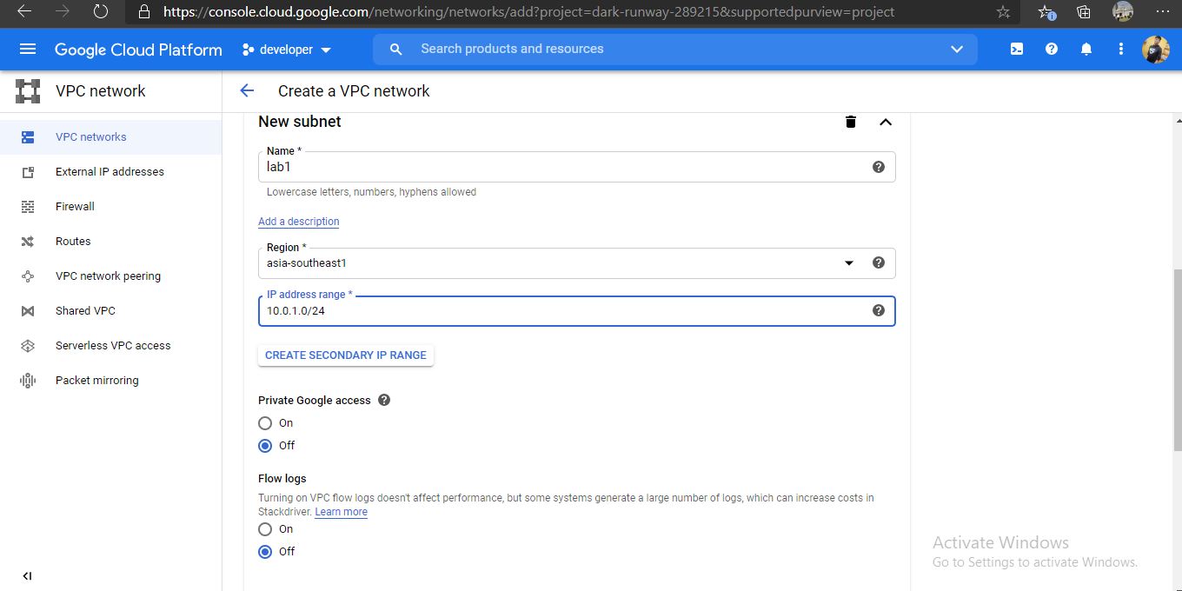

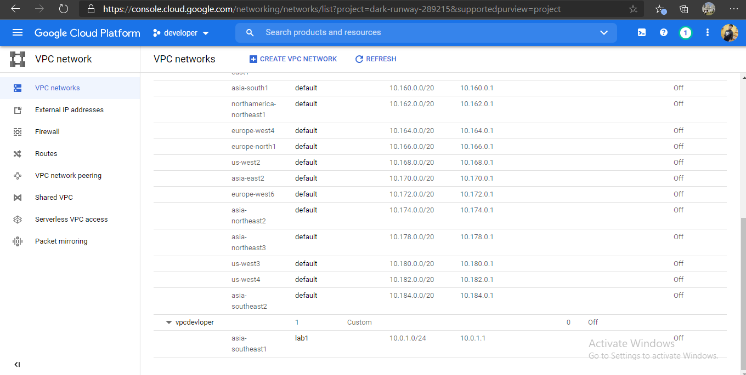

For another project “production” we create vpc in us-east1 region as lab2

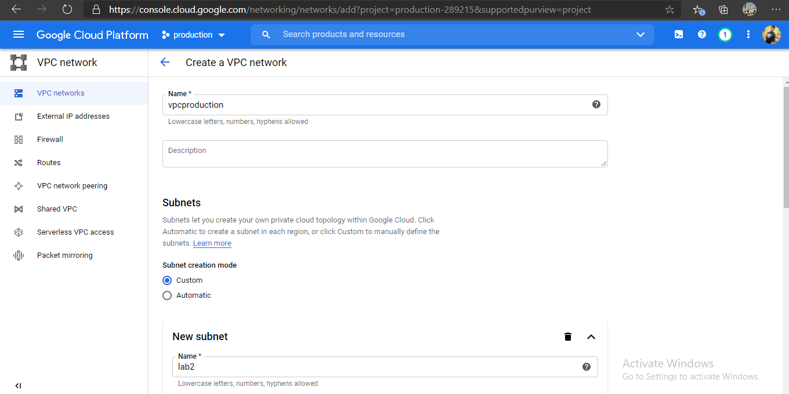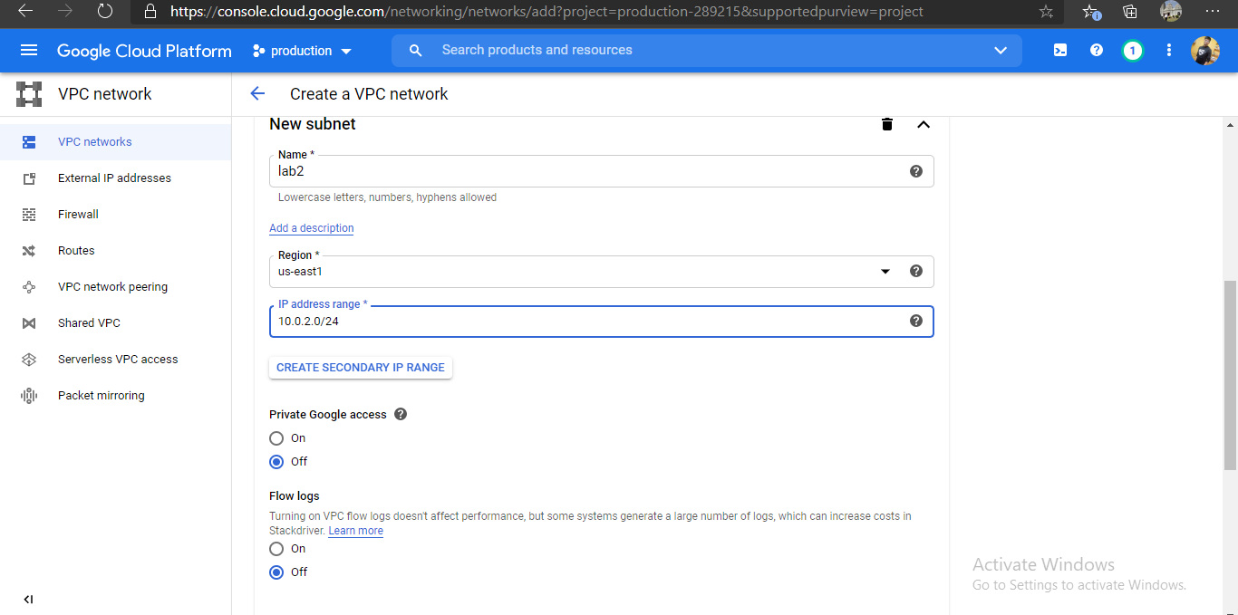

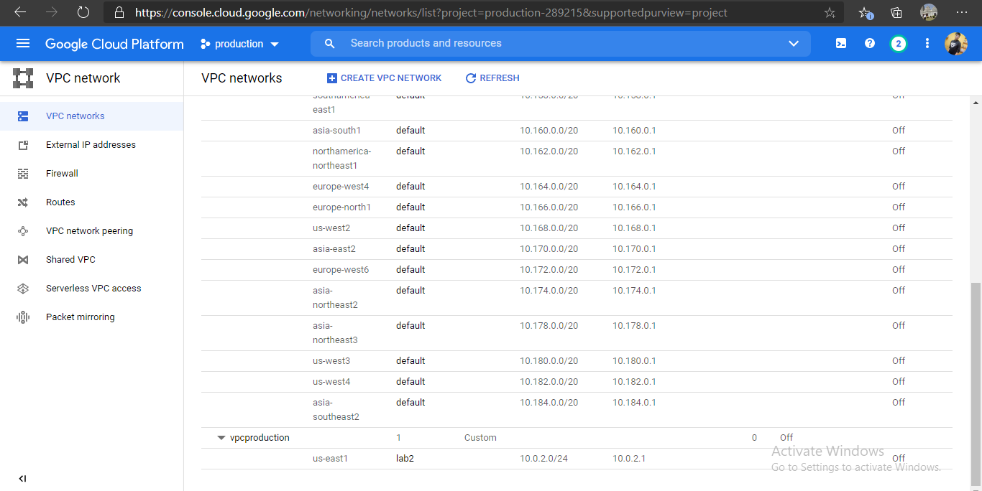

Now we have to create firewall in both the vpc network

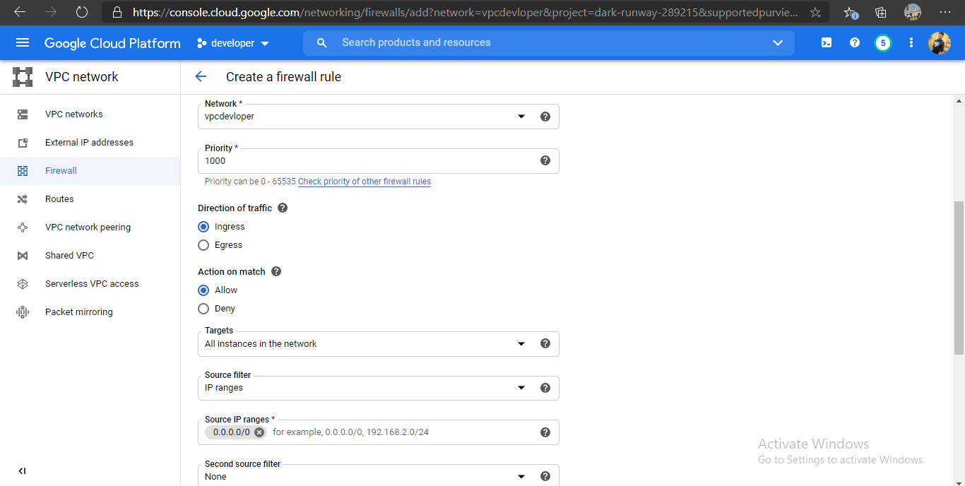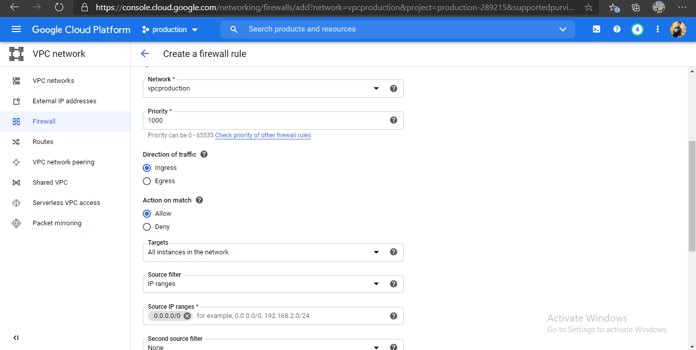

Task 3.Create a link between both the VPC networks using VPC Peering

At first we have to create peering connection in both the projects and share the project id and vpc network in each other projects:

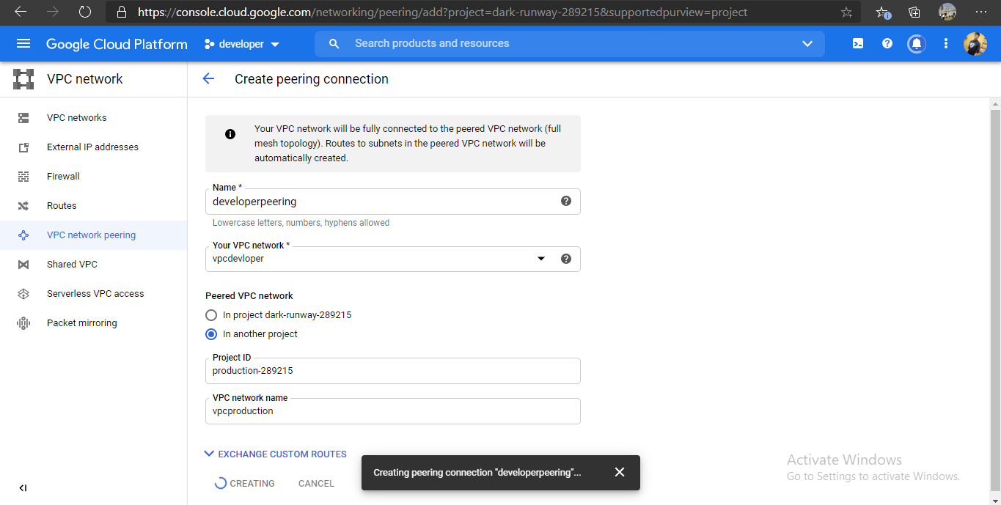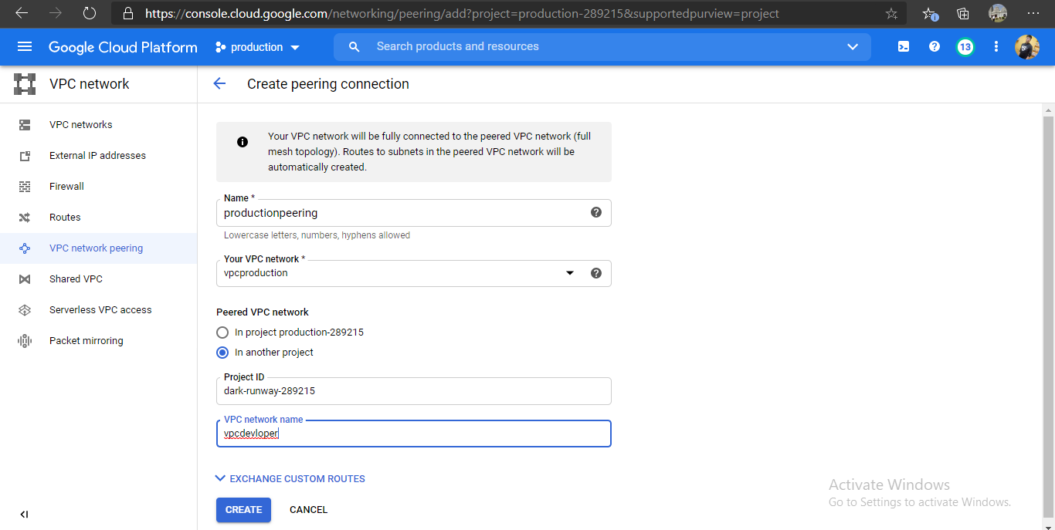

So, now our VPC peering is established between the vpc network of both the projects and showing as active.

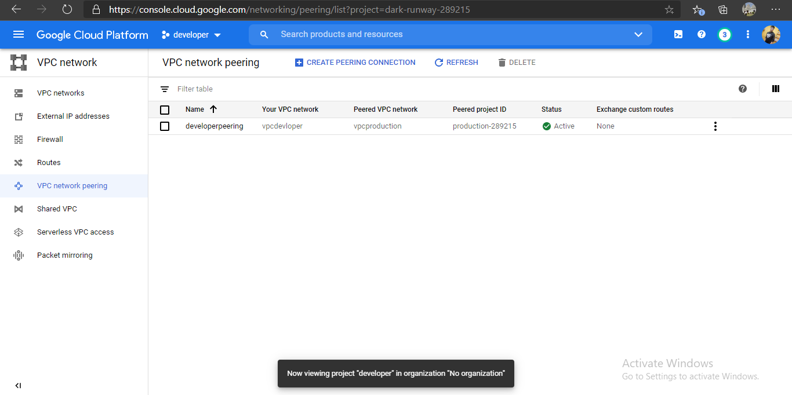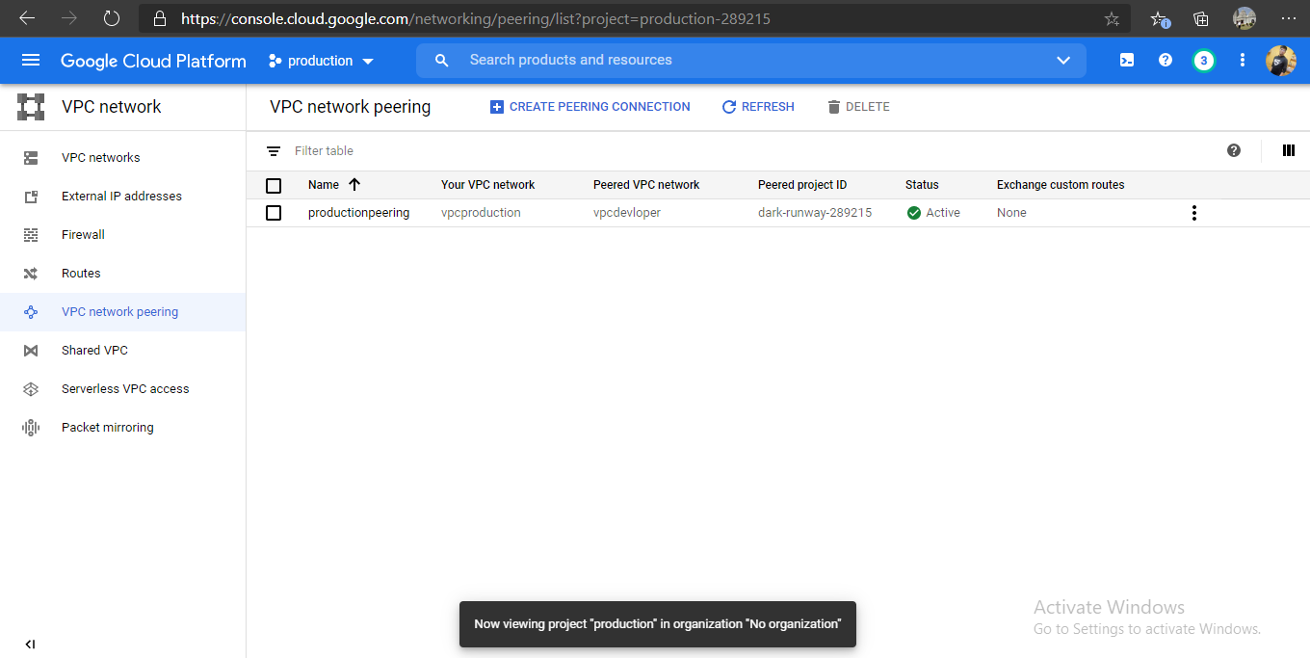

Task 4. Create a Kubernetes Cluster in developer project and launch any web application with the Load balancer

At first create a Kubernetes Cluster in the project developer:

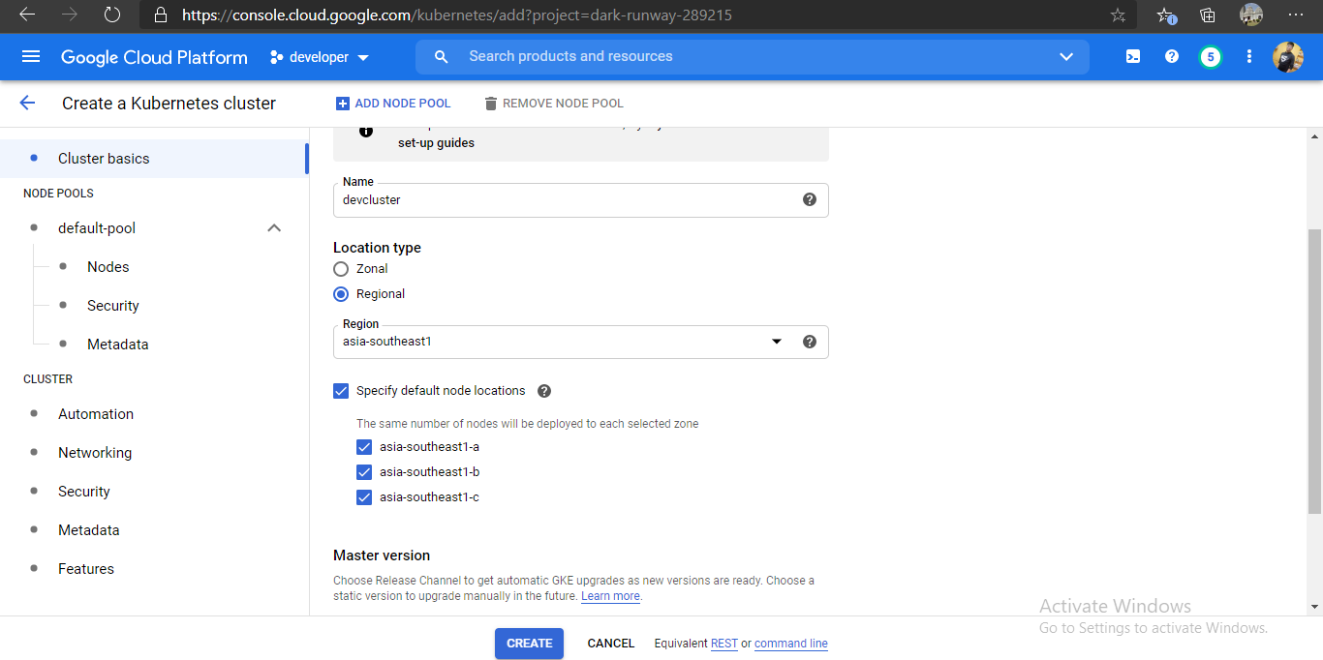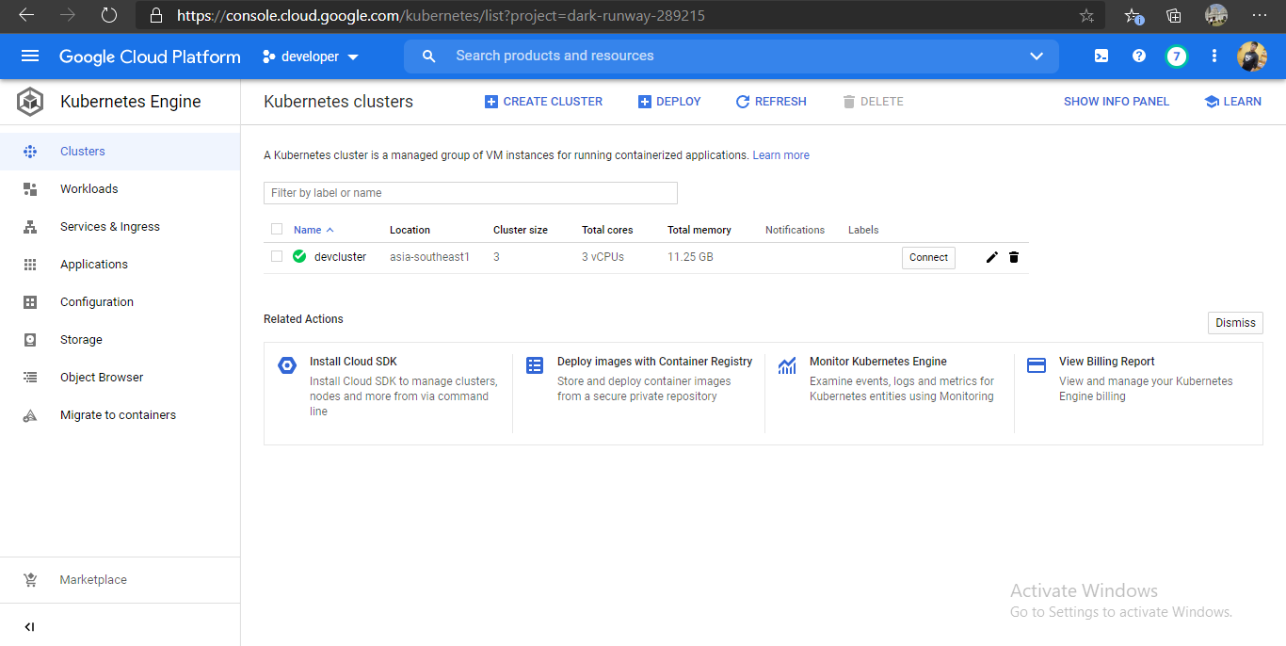

Our cluster is ready.

Now we have to configure kubectl with gcloud and we can do that by launching one command. Click on “Connect” button in front of newly created Kubernetes Cluster.

Use “kubectl config view” command to config in shell

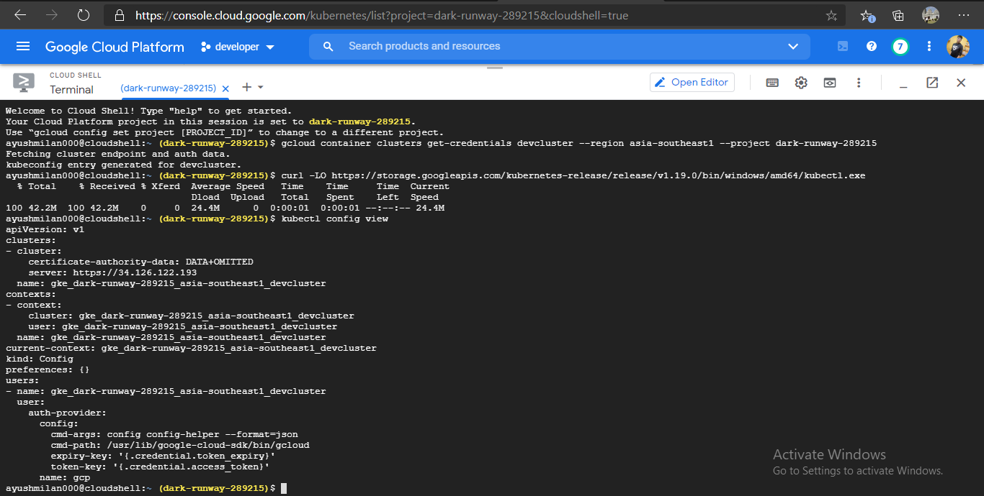

Use command- kubectl get nodes and then deploy our web application,here i am using WordPress docker image for creating my own blogging website.

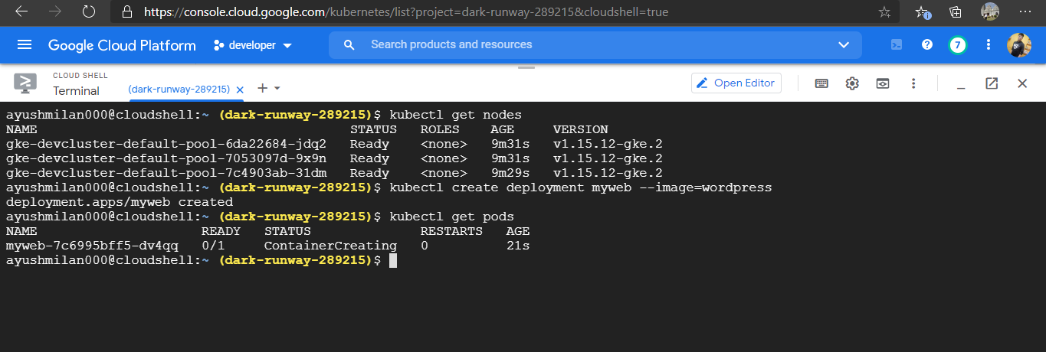

Next we have to check the status of pods launched and get all the information about all pods:

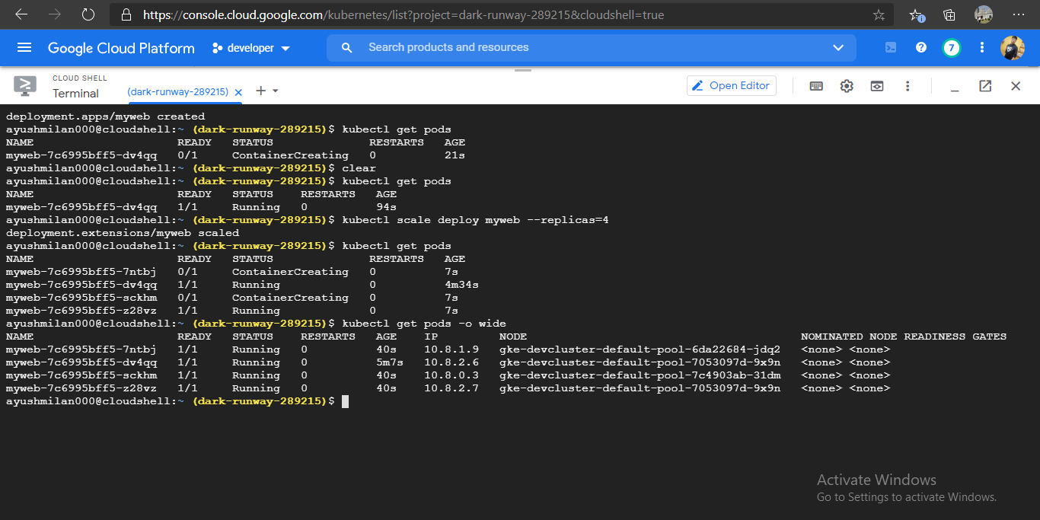

Now we have to add a Load Balancer to handle the task smoothly. Load Balancer automatically manage the resources

Use command : kubectl expose deployment your_deployment_name --type=LoadBalancer -- port=80

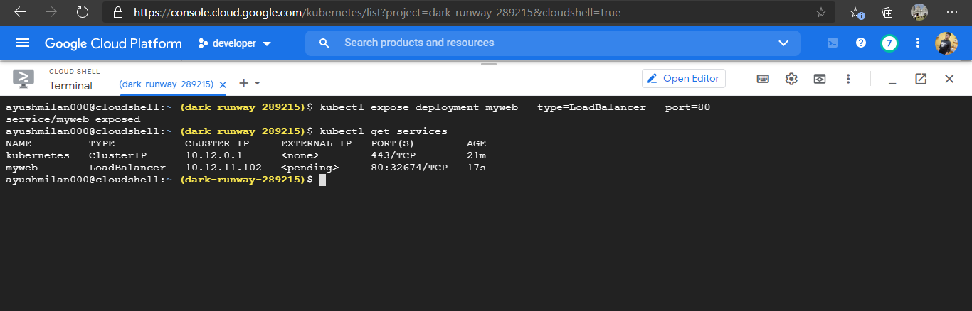

Task 5. Create a SQL server in the production project and create a database

Task 6.Connect the SQL database to the web application launched in the Kubernetes cluster

Create a mysql instance database:

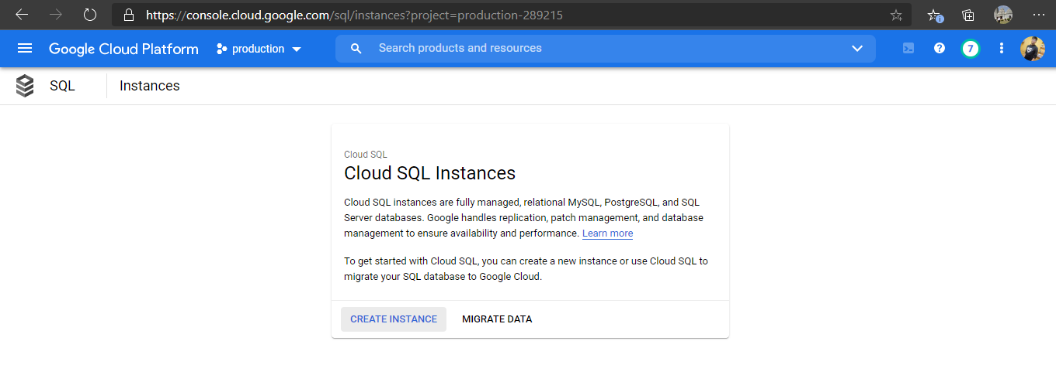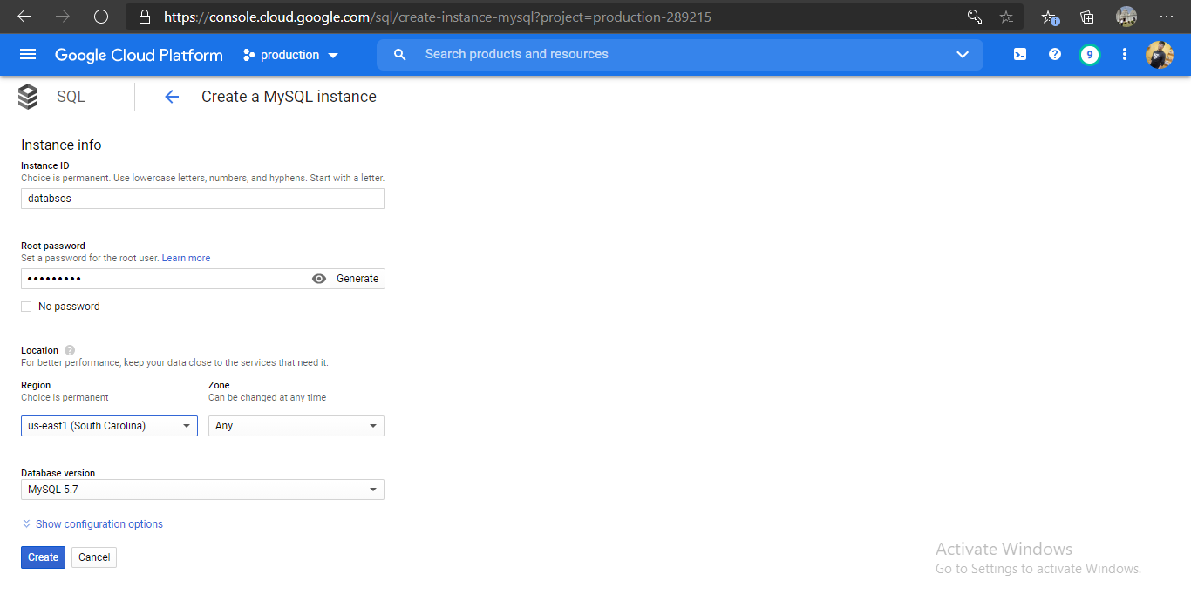

After creating the database go to edit configuration :

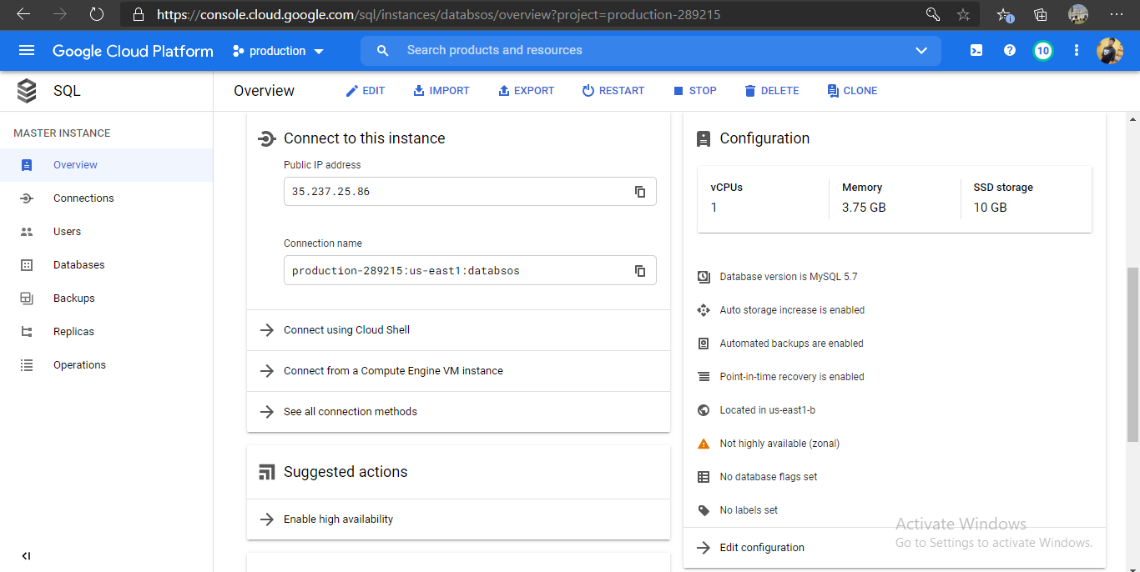

enable the public ip address:

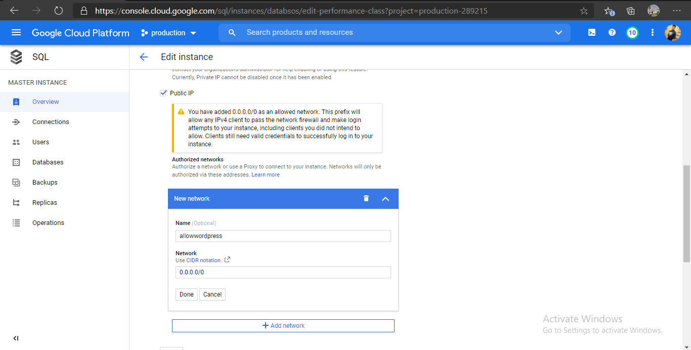

Create Database for our WordPress website :

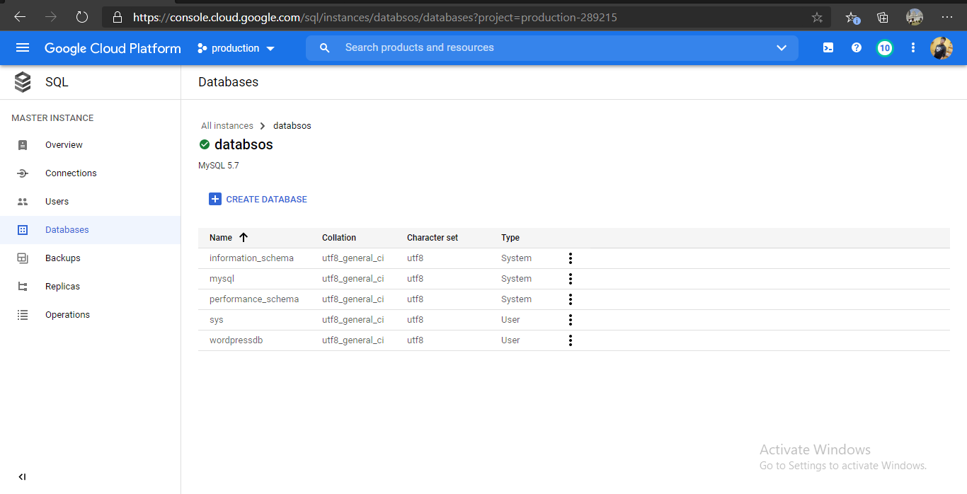

Now login using Cloud Shell to MySQL Instance:

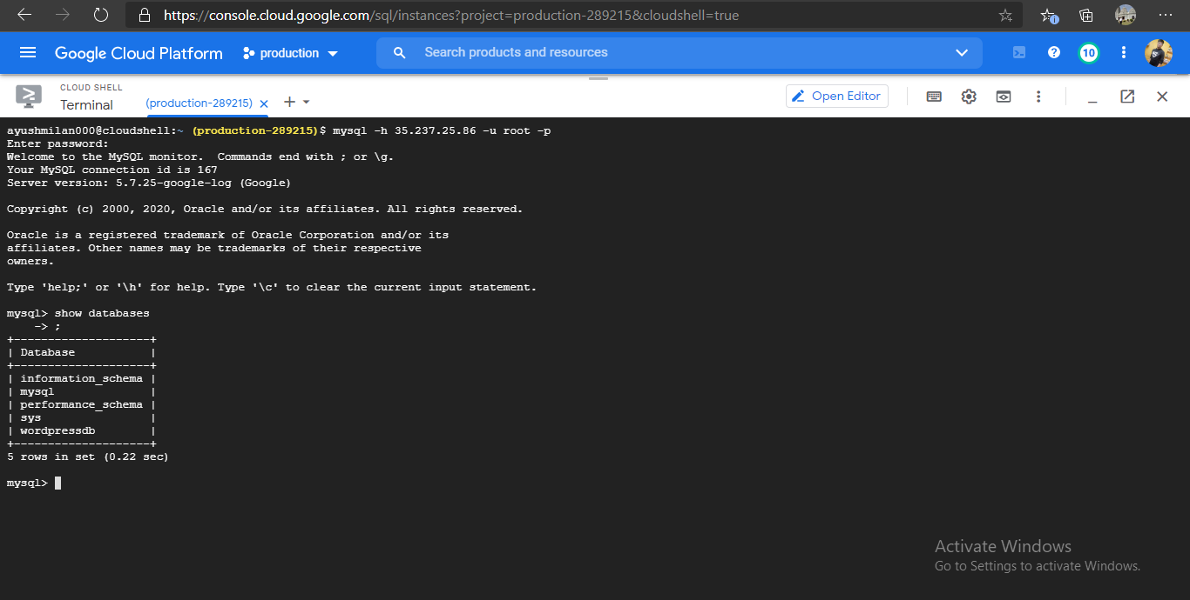

Next ,using the ip address provided by Load Balancer, access the website. Setup WordPress to MySQL server and then we can start blogging on our own website over Public Network.

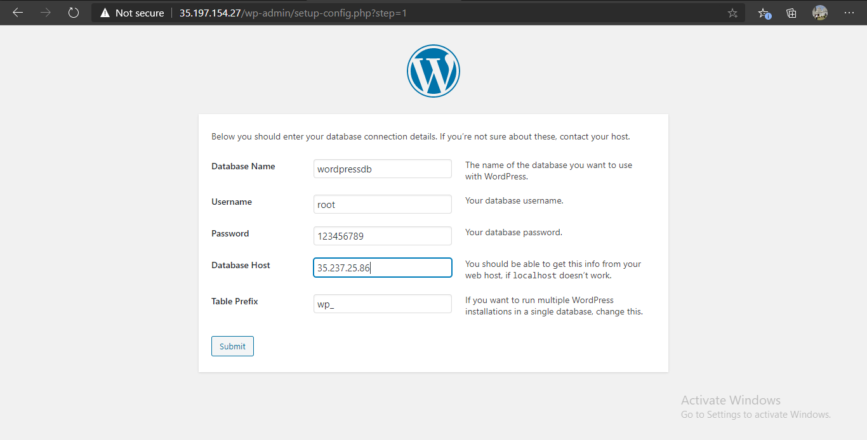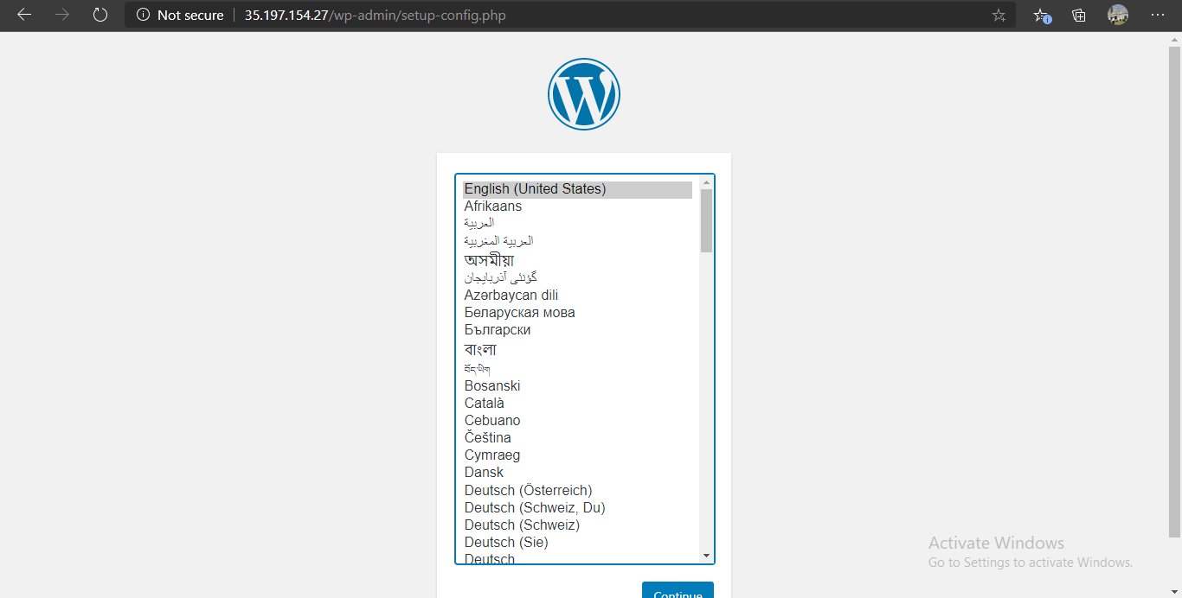

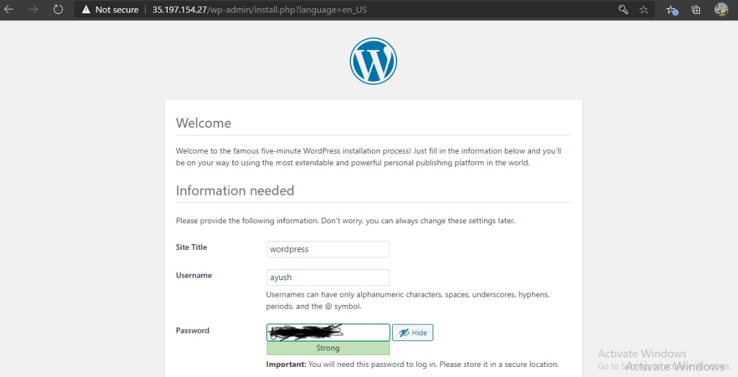

Login with credentials you created while setup:

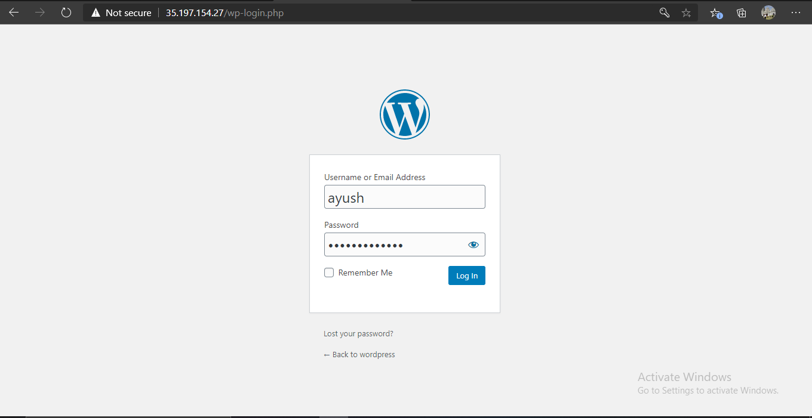

Our website is ready, we can utilize it:

